SCORES N MORE
AKC Annually Licensed Agility Trial Secretary
Cyndi Kepner
118 School Street
Burnham PA 17009

Event #2010211305 Event #2010211306
 | October 2 - 3, 2010  Lancaster  Kennel Club  AKC Member Club Agility Trials  All akc breeds (no mixed Breeds)  330 runs per judge,per day  Total 660 runs / day  2 rINGS / inDOORS /  sprint turf

Entries OPEN: Monday, Aug. 2, 2010 @ 8 AM (First Rec’d Method)
Entries CLOSE: Saturday, Sept. 11 2010 @ 5 PM
No entries will be accepted before this date and time. No Online, FAX or email entries accepted. No credit card payments accepted.
SCORES N MORE
AKC Annually Licensed Agility Trial Secretary

Entries close at the Trial Secretary’s address on Sat. Sept. 11, 2010 at 5 PM after which time entries cannot be accepted, cancelled or substituted, except as provided for in Chapter 11, Section 6 of the Dog Show Rules.
All express mail must be marked “NO SIGNATURE REQUIRED”. Secretary NOT responsible for entries NOT arriving on time. Maximum of ten entries per envelope. Envelopes exceeding 10 dogs are invalid and will be returned.

NEW LOCATION : IN THE NET
798 Airport Rd., Palmyra, PA 17078

All judging will be ALL BREEDS (no mixed) / INDOORS
Surface: Indoor / Sprint Turf
Ring 1: STD –100’ x 100’, Ring 2: JWW – 100’ x 100’
Trial Hours: 7 AM to 7 PM
Judging starts 8:00 AM


--- Certification ----
Permission has been granted by the American Kennel Club for the holding of this event under American Kennel Club Rules and Regulations
- James Crowley, Secretary

LANCASTER KENNEL CLUB
P.O. Box 7511, Lancaster, PA 17604-7511

President:.......Bernie Ferry
Vice-Pres:….Mark Bair
Secretary:…..Tammy Selka 1818 Lincoln Hwy. East, Lancaster PA 17602-3341
Treasurer: ….Ann Byrne
Directors: …Jeff Clinite, Marybeth Acker, Deb Eckert, Hank Hillard, Gail Hillard

Chairman  Hank Hillard  437 S. Plum St.  Mount Joy, PA 17552  (717) 314-2975  Adare437@comcast.net | Trial Committee  Hank Hillard  Joy Ellwanger  Gail Hillard  Mary Lou Strayer  Irene Lehan
Campers  Hank Hillard  (717)314-2975 | Vendors  Hank Hillard  (717)314-2975

SCORES N MORE AKC Annually Licensed Trial Secretary
Cyndi Kepner (Associate with Bonnie Reifsnyder)
118 School Street, Burnham, PA 17009 (717) 242-0578
cyndi@scoresnmore.com / ckrotteez@verizon.net www.scoresnmore.com

Judges
H.A. (Rob) Robinson, 867 N Union Rd., Dayton OH 45427-1522
Kandy B Robinson, 867 N Union Rd., Dayton OH 45427-1522

Sat: 26” – 4” Sun: 26” – 4”
Ring 1 8:00 Saturday Oct. 2, 2010 Ring 2 8:30
Kandy Robinson | Rob Robinson
FAST - Open, Novice (B, A, P) | FAST - Excellent (B, A, P)
STD – Excellent, Open, Novice (B,A,P) | JWW – Open, Novice, Excellent (B, A, P)
Ring 1 8:00 Sunday Oct. 3, 2010 Ring 2 8:30
Rob Robinson | Kandy Robinson
FAST - Open, Novice (B, A, P) | FAST - Excellent (B, A, P)
STD – Excellent, Open, Novice (B,A,P) | JWW – Open, Novice, Excellent (B, A, P)

Equipment and E-timers provided by
M.A.D. Agility Equipment
Mark and Jennifer Dreese: McClure, PA 717-543-5693
www.madagility.com

24” WEAVE POLES WILL BE USED

VET ON CALL: Palmyra Animal Hospital Clinic
920 E. Main St, Palmyra, PA 17078 (717-838-5451)

Directions to IN THE NET
In The Net (indoor soccer field) is located just off RT 117 (Forge Rd). Turn onto Airport Road at the intersection at REIGLE’S AIRPORT and we are located on your RIGHT less than a mile away from REIGLE’s AIRPORT.

FROM THE NORTH:(Northern New Jersey / New York / Wilkes Barre / Scranton)
I-78 W to I-81 S to Exit 29A RT 934 S to Route 322 W to Route 117 N. Turn right on Airport Road.

FROM THE SOUTH: (Baltimore / York)
I-83 N to RT 322 At Harrisburg to RT 117 N. Turn right on Airport Road.

FROM THE EAST: ( S New Jersey / Philly / Reading)
PA Turnpike (I-76) West to Exit 266 to RT 72 N to RT 322 W to RT 117 N. Turn right on Airport Road.

FROM THE WEST: ( Ohio / Pittsburgh / Carlisle)
PA Turnpike (I-76) East to Exit 266 to RT 322 W to RT 117 N. Turn right on Airport Road.

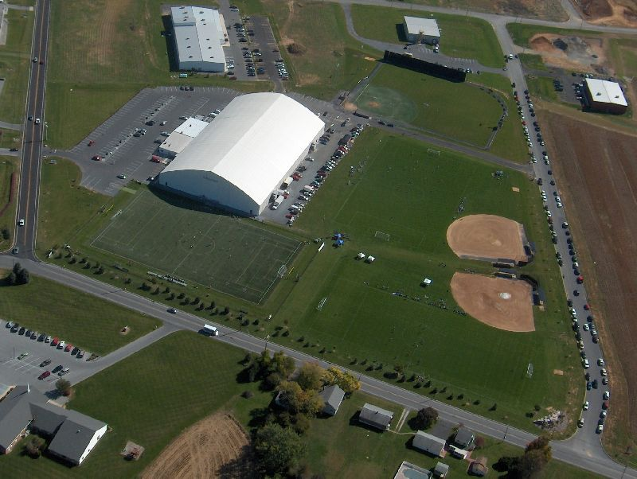
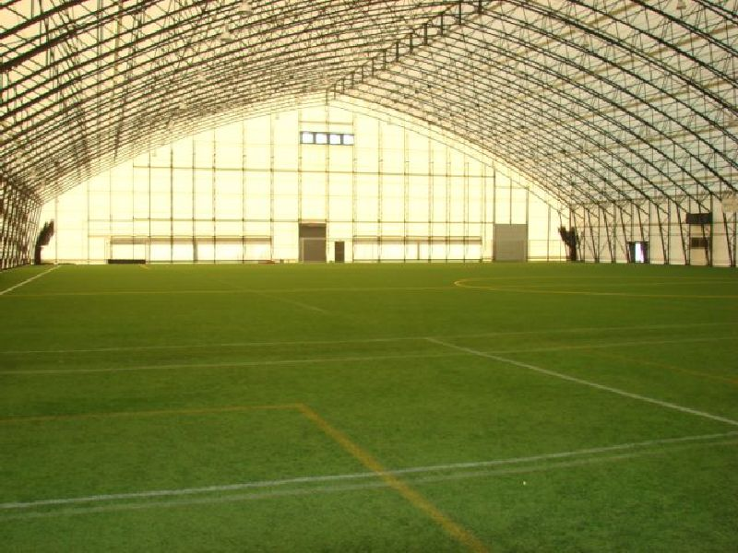

Motels: Remember to call ahead for Pet Policies!
CAMPING by pre-registration only No refunds. No Hook ups
- Self Contained RV’S: $20/day First come first serve basis
- NO TENTS
- Mail form with payment to: LKC , c/o Hank Hillard, 437 S Plum St, Mount Joy PA 17552.

Campers Name __________________________________ Phone _____________________

Email Address _______________________________________________________________

Days:
[ ] Friday ( ) Camper/RV ($25/day) (Self contained ONLY – No Hook ups)

[ ] Saturday Size (length) _________________

Make/Model _________________

Plate Number _________________

State _________________

Comfort Inn - Exit 81 off I-81: 717-540-8400
7744 Linglestown Rd., Harrisburg PA 17112

Econo Lodge - RT 743, Exit 79 off I-81: 717-469-0631
252 Bow Creek Rd., Grantville, PA 17028

Holiday Inn - RT 743, Exit 79 off I-81: 717-469-0661
604 Station Rd., Grantville PA 17028

Palmyra Motel – 2 miles from site: 717-838-1324
East Main St., Palmyra, PA 17078

Motel 6 – 4 miles from site: 717-533-2384 / hersheymotel6@yahoo.com
East Chocolate Ave., Hershey PA 17033

Highmeadow Camp Ground: 717-534-8999
Hershey Park Drive, Hershey PA, 17033

CLASSES AND DIVISIONS
CLASS | REGULAR | PREFERRED
STANDARD | Novice A & B, Open, Exc A & B | Novice P, Open P, Exc AP & BP
JUMPERS WITH WEAVES | Novice A & B, Open, Exc A & B | Novice P, Open P, Exc AP & BP
FAST | Novice A & B, Open, Exc A & B | Novice P, Open P, Exc AP & BP

Please see the AKC Regulations for Agility Trials for current class descriptions. Dogs must be entered only in Regular Classes or Preferred Classes with no crossover between them allowed at the same set of trials.

FOR MORE INFORMATION ABOUT CLASSES, RULES ETC

GO TO: http://www.akc.org/dic/events/agility

HEIGHT DIVISIONS

Regular Exhibitors may choose to enter their dog in a higher height division than required by AKC, but not in a height division lower than the AKC mandated height
Preferred -The following jump heights must be used in all Preferred Classes.

Regular Preferred
Dogs 11 inches and under at the withers 8 inches 4 inches
Dogs 14 inches and under at the withers 12 inches 8 inches
Dogs 18 inches and under at the withers 16 inches 12 inches
Dogs 22 inches and under at the withers 20 inches 16 inches
Dogs over 22 inches at the withers 24 inches 20 inches
Dogs may be entered at owner discretion 26 inches

PRIZES
1st Place | Blue Rosette | Also Offered:
2nd Place | Red Rosette | New Title Ribbons / Rosettes  MACH Rosettes / MACH Bars  PAX Rosettes / PAX Bars
3rd Place | Yellow Rosette
4th Place | White Rosette
Qualifying | Green Flat Ribbon

MACH blankets will also be given to those earning the MACH title at this trial. Compliments of SCORES N MORE Trial Secretaries
Cyndi Kepner and Bonnie Reifsnyder

Day to Day Move Ups Accepted!
Dogs may be moved up to a higher class at the request of the owner, as the result of qualifying for an agility title, provided the request is made in writing or by email to the Trial Secretary by 6PM on Monday, Sept. 27, 2010 for Saturday and by 10 min. after last run each day for Daily move ups. Dogs must be entered on Saturday to submit a Day-to-Day move up for Sunday.

Eligibility Statement

This trial is open to all dogs over the age of 15 months that are registered with the American Kennel Club or are registerable breeds that have obtained an ILP/PAL number from AKC, except bitches in season, aggressive dogs, blind or deaf dogs, or dogs suffering from any deformity, injury or illness which may affect the dog’s physical or mental performance.

If you would like to know the status of your entry, Please enclose a self-addressed stamped envelope, postcard or valid and legible email address with your entry. Please be patient, as entries are processed you will be notified of your status.

Exhibitors should follow their veterinarians’ recommendation to assure their dogs free of internal and external parasites,any communicable diseases, and have appropriate vaccinations.”

M.A.D AGILITY EQUIPMENT
will be supplying the equipment and
electronic timing for our rings.
They can be contacted at www.madagility.com or
by phone at (717) 543-5693.
24” WEAVE POLES WILL BE USED

All exhibitors should obtain a copy of the Regulations for Agility Trials by contacting the American Kennel Club, 8051 Arco Corporate Drive, Suite 100, Raleigh, NC 27617-3390, by phone (919) 233-9767, by email at info@akc.org, or on their website at www.akc.org.

NOTICES TO EXHIBITORS - PLEASE READ BEFORE ENTERING

- NO ALCOHOLIC BEVERAGES PERMITTED ON SHOW GROUNDS.
- All dogs must be on leash when not competing in the ring or at the practice jump.
- No entry shall be made and no entry shall be accepted which specifies any condition as to its acceptance.
- Exhibitors, through submission of entry, acknowledge that they are familiar with AKC agility rules and regulations and that their dogs are familiar with and able to perform all obstacles safely.
- No Refunds for Bitches in Season, Injured Dogs or Injured Handlers/Owners.
- No entry fee will be refunded if the trial cannot open or be completed by reason of riots, civil disturbances, fire, an act of God, public emergency, act of a public enemy, or any other cause beyond the control of the organizing committee.
- Telegraph, telephone, email, AKC online entries, fax, and unsigned entries will not be accepted.
- All calls to the Trial Secretary must be before 9 PM.
- Entries not on official AKC entry forms and photocopies of entry forms without agreement and rules printed on the reverse side of the Official AKC Entry Form are NOT acceptable and will be returned!
- Postdated checks and returned checks do not constitute a valid entry fee. The club treasurer will add a collection fee of $30.00 to the amount of each returned check.
- Owners are responsible for errors in making out entry forms. Entry fees do not have to be refunded in event of such error.
- Exhibitors are responsible for cleaning up after their dogs at the show site. Failure to do so will result in dismissal.
- Dogs may arrive any time prior to their scheduled time of judging. Dogs not required for further judging will be excused.
- Judges will not wait for any dog holding up the judging schedule. Owners or agents alone are responsible for the presence of their dogs in the agility ring when they are called to be judged.
- It is expressly understood that every dog and child at this trial are in the care, custody and control of its owner, handler, or parent during the entire time the dog or child is on the trial premises. Any exhibitor whose dog and/or child create unnecessary disturbances or repeatedly engage in unsafe or disruptive behavior, may, at the discretion of the Trial Committee, be asked to leave the show site. In such case, no refund of any fees will be made.
- Neither LKC nor IN THE NET are responsible for the loss of, damage to, or death of any dog exhibited, or the possessions of any participant, whether the result of accident or any other cause.
- Exhibitors should follow their veterinarians’ recommendation to assure their dogs are free of internal and external parasites, any communicable diseases, and have appropriate vaccinations.
- ENTRY FEE $24 for the first entry of a dog, $14.00 for each additional entry of the same dog per day. (includes $3.00 AKC recording Fee for the first class and $3.00 for each additional class of each day)
- Declination of Entries: The Lancaster Kennel Club may decline any entries for cause and may refuse to receive or may remove dogs on account of disease, viciousness or other causes and no one shall have any claim or recourse against the Lancaster Kennel Club or any official thereof.
- Trial Secretary is not responsible for incorrect information on any entry. Trial Secretary is not responsible for entries or emails not received on time or not received at all.

OFFICIAL ENTRY FORM FOR AGILITY TRIALS

LANCASTER KENNEL CLUB
IN THE NET
PALMYRA PA
SATURDAY 10-2 [ ] STD [ ] JWW [ ] FAST [ ] ALL 3 $52
SUNDAY 10-3 [ ] STD [ ] JWW [ ] FAST [ ] ALL 3 $52
Make Checks payable to LKC
Entry Fees: $24 for first class, $14 add’l entry / Same dog / Same day
(includes $3 and $3 AKC recording fees)
Entries OPEN : AUG 2, 2010 / 8 AM Entries CLOSE: SEPT 11, 2010 / 5 PM
Mail Entry to : Cyndi Kepner , 118 School St. , Burnham PA 17009
IMPORTANT: carefully read instructions on reverse side before filling out) height at
breed sex [ ] My dog needs to be measured withers
                [ ] My dog has a Temporary Jump Height Form
               [ ] My dog has a Permanent Jump Height Card
regular standard agility regular jumpers with weaves regular fast
(circle one) (circle one) (circle one)
nov-a nov-b open exc-a exc-b nov-a nov-b open exc-a exc-b nov-a nov-b open exc-a exc-b
jump height (circle one) 8 12 16 20 24 26
preferred standard agility preferred jww preferred fast
(circle one) (circle one) (circle one)
novice-p open-p exc-ap exc-bp novice-p open-p exc-ap exc-bp nov-p open-p exc-ap exc-bp
jump height (circle one) 4 8 12 16 20
non-regular agility classes (if offered): international sweepstakes class jump height (circle one)
Not offered (circle class) std jww 14 18 26
akc® name (Include AKC titles only) call name of dog
(Enter number below) date of birth
[ ] akc® no.
[ ] ilp [ ] pal place of birth (List Country)
[ ] foreign reg. no.
breeder
sire
dam
actual owners
owners address  new address

city, state, zip + 4
handler If Junior Handler, please enter # below fee enclosed

Exhibitor / Owner must read and sign the reverse side of this form.
*Clubs are eligible to offer mixed breed classes at agility trials beginning April 1, 2010.
AKC Rules, Regulations, Policies and Guidelines are available on the American Kennel Club Web site, www.akc.org

AGREEMENT
I (we) agree that the club holding this event has the right to refuse this entry for cause which the club shall deem sufficient. In consideration of the acceptance of this entry and of the holding of this event and of the opportunity to have the dog judged and to win prizes, ribbons, or trophies, I (we) agree to hold the AKC, the event-giving club, their members, directors, governors, officers, agents, superintendents or event secretary and the owner and/or lessor of the premises and any provider of services that are necessary to hold this event and any employees or volunteers of the aforementioned parties, and any AKC approved judge, judging at this event, harmless from any claim for loss or injury which may be alleged to have been caused directly or indirectly to any person or thing by the act of this dog while in or about the event premises or grounds or near any entrance thereto, and I (we) personally assume all responsibility and liability for any such claim; and I (we) further agree to hold the aforementioned parties harmless from any claim for loss, injury or damage to this dog.
Additionally, I (we) hereby assume the sole responsibility for and agree to indemnify, defend and save the aforementioned parties harmless from any and all loss and expense (including legal fees) by reason of the liability imposed by law upon any of the aforementioned parties for damage because of bodily injuries, including death at any time resulting therefrom, sustained by any person or persons, including myself (ourselves), or on account of damage to property, arising out of or in consequence of my (our) participation in this event, however such, injuries, death or property damage may be caused, and whether or not the same may have been caused or may be alleged to have been caused by the negligence of the aforementioned parties or any of their employees, agents, or any other persons. I (we) agree that any cause of action, controversy or claim arising out of or related to the entry, exhibition or attendance at the event between the AKC and the event-giving club (unless otherwise stated in its premium list) and myself (ourselves) or as to the construction, interpretation and effect of this Agreement shall be settled by arbitration pursuant to the applicable rules of the American Arbitration Association. However, prior to arbitration all applicable AKC Bylaws, rules, regulations and procedures must first be followed as set forth in the AKC Charter and Bylaws, rules, regulations, published policies and guidelines.

INSTRUCTIONS

Handlers may opt to enter in a higher height division for all Regular titling classes, but not in a division lower than their proper height division. Dogs entered in the Preferred classes must compete at the required jump height and may not compete in a jump height division higher or lower than their proper height division.
All dogs that have not been officially measured for an Agility Jump Height Card may still compete; however, they must be measured by a Judge of record, an Agility Field Representative, or a Volunteer Measuring Official, prior to running. If measured by the Judge of record, that measurement will be valid for this trial or back-to-back trials only. If a measurement is necessary, it is the exhibitor's responsibility to have their dog(s) measured prior to running.
Mixed breed classes may only be offered at standalone all-breed AKC agility trials. A standalone agility event is defined as an agility trial that is not held on the same date and show site as an AKC All-Breed Dog Show or Independent Specialty for conformation.
Junior Handlers should enter their Junior Handler number on the front of this form. Should you not have your Junior Handler number, it may be obtained from the American Kennel Club (919) 816-3776. If the Junior Handler is not the owner of the dog identified on the face of this form, what is the relationship is the Junior Handler to the Owner?
I CERTIFY that I am the actual owner of the dog, or that I am the duly authorized agent of the actual owner whose name I have entered above. In consideration of the acceptance of this entry, I (we) agree to abide by the rules and regulations of The American Kennel Club in effect at the time of this event, and by any additional rules and regulations appearing in the premium list for this event, and further agree to be bound by the "Agreement" printed above on this entry form. I (we) certify and represent that the dog entered is not a hazard to persons or other dogs. This entry is submitted for acceptance on the foregoing representation and Agreement. I (we) agree to conduct myself (ourselves) in accordance with all such Rules and Regulations (including all provisions applying to discipline) and to abide by any decisions made in accord with them.
Signature of owner or his agent duly
authorized to make this entry _____________

telephone :

e-mail address: ________________________________________________________________________________
AEAGL2 - (07/09)

Trial Volunteer Form
Our club is in need of volunteers to help run this trial. Any help you could provide would be greatly appreciated. Worker Coordinator will be Mary Lou Strayer: maryloustrayer@aol.com

We will do our best to accommodate your choices. You can view a workers schedule at www.scoresnmore.com a few days prior to the trial. Please contact worker coordinator if you can not fulfill your assignment.

Your Name:

Dog’s Jump Height(s):____________ ____________ ____________

E-mail: _____________________________________________

Phone:_______________________________

How many are you willing to work each day? ________

Please circle the jobs below to indicate positions you are willing to fill:
Course Builder  Ring Crew  Scribe |  |  |  |  | Asst. Scribe  Gate Steward  Timer |  |  |  |  |  | Leash Runner  Score Sheet Runner
Please indicate the classes you are entered in by writing the
Jump Height in the appropriate box for that class for each day:
 | SAT |  |  | SUN
 | STD | JWW | FAST | STD |  | JWW | FAST
NOV
OPN
EXC
# of dogs running / day:_____________

All workers must check in at the worker’s tent upon arrival at the trial to receive their meal tickets.

THANK YOU IN ADVANCE,
Lancaster Kennel Club Agility Trial Committee
Move Up Form
As per Section 13, American Kennel Club Regulation for Agility Trials, dogs may be moved up to a higher class, at the request of the Owner, as a result of qualifying for an agility title. Dogs so moved up will be entered at the end of the running order or otherwise at the secretary’s or Judges discretion.

PLEASE READ THE MOVEUP SECTION

NOVICE MOVEUPS: Dogs having attained their first AKC Agility Title (STD, JWW or FAST) must be moved to the Nov B Class (STD and JWW) for all trials that have not reached the closing date. Once a trial closing date has past, a dog cannot be moved from Nov A to Nov B. If the trial has already reached the closing date on the day the dog obtained its title, the dog shall remain in the class in which it was originally entered. The dog can also be moved up a level (Nov to Open) at the request of the owner subject to the normal move-up criteria.

Before the trial, move-ups may be made prior to the move-up deadline via email to ckrotteez@verizon.net, or in writing to Cyndi Kepner, 118 School St. Burnham, PA 17009. Verbal move ups will not be accepted.

Move ups are due in writing by the Monday , 9/27/10 at 6 pm the week of the trial.
Day-to-Day Move-ups are only allowed for dogs entered at the set of back-to-back agility trials for succeeding days of that set of back-to-back agility trials and must be submitted in writing at the trial within 15 min of the last run of the trial day for the following day(s) and can not be conveyed via fax, email, or verbally – they must be given to the Trial Sec. in writing that day (forms will be available in the MOVE UP BOOK provided near Score Postings).

Trial Date: ______________________________________

Owner’s Name________________________________________

Reg. #:____________________________ Call Name:______________________

Breed:________________________

Arm Band #:_______________ (If Available)

Move Up To:

STANDARD:____________________________ A B P AP BP
(circle one)

JWW:_________________________________ A B P AP BP
(circle one)

FAST:________________________________ A B P AP BP
(circle one)

REMINDER: If you are the score sheet runner, you must be the only person to hand deliver the scribe sheets to the score table during the class you are assigned to work in that position. Any changes need to be approved through the worker coordinator.

